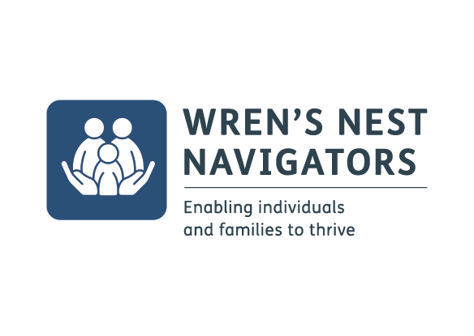
Wren’s Nest Navigator Project – Self Referral Form
First Name: |  | Surname:
Date of Birth: |  | Contact number:
Address including postcode:
Email Address:
School/College
Gender: |  | Ethnicity:
Does the child/young person or main family contact have additional needs that we need to be aware of?
Date of referral:
Emergency Contact Details/Named Contact for children 16 years and under:
First Name: |  | Surname:
Date of Birth: |  | Contact Number:
Relationship to referral: |  | Email Address:
Address including postcode:
Interests and support
Please tick the following options that you are interested in:
Mental Wellbeing Workshops ☐ Creative Workshops ☐
Physical activity ☐ Pre – employability Learning and skills ☐
Money Management advice ☐ Cook and Eat activties ☐
Health and Nutrition advice ☐

Reason for referral to Wren’s Nest Navigators:

Please sign here to give your consent to be contacted to discuss this referral and your engagement with the project:
Name |  | Signature:

If this referral is on behalf of a child or young person (16 years and under) please sign here to give your consent for this referral and to be contacted by the project team:

Name |  | Signature:

Please return the completed form to: dudleywrensnest@ymcabc.org.uk

We look forward to meeting you soon!

Follow us for further updates and changes to the timetable:
@dudleywrensnest
@dudleywrens

