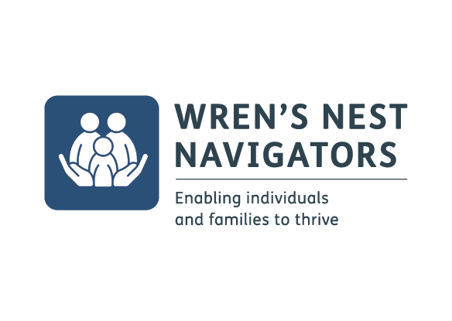

Wren’s Nest Navigator Project – Self Referral Form
Name: |  |  | Surname:
Date of Birth: |  |  | Contact number:
Gender: |  |  | Postcode:
Address:
Email Address:
School/College
Date:

Emergency contact details:
First name: |  |  | Surname:
Date of Birth: |  |  | Tel:
Gender: |  |  | Postcode:
Address:
Email Address:
Date:

Interests and support
Please tick the following options that you are interested in:

Mental Wellbeing Workshops ☐
Pre – employability Learning and skills ☐
Cook and Eat activties ☐
Health and Nutrition advice ☐
Creative Workshops ☐
Physical activity ☐
Money Management advice ☐
Counselling ☐

Reason for referral to Wren’s Nest Navigators:

Please sign here to confirm your consent to contacted to discuss this referral.
Name |  | Signature:

If this referral is on behalf of a young person please sign here:

Name |  | Signature:

Please return the completed form to: dudleywrensnest@ymcabc.org.uk

We look forward to meeting you soon!

Follow us for further updates and changes to the timetable:
 | @dudleywrensnest |  | @dudleywrens

