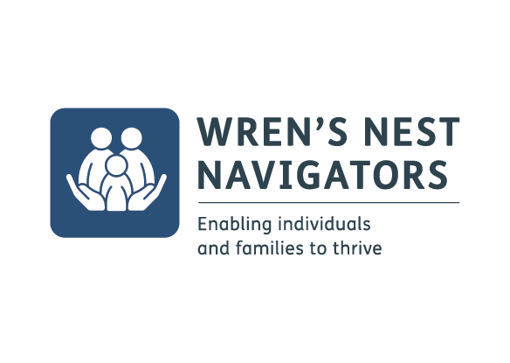

VOLUNTEER APPLICATION FORM

Personal Details

Name
ID Number (for internal use only)
Address
Postcode
Home telephone
Mobile
Email address

Driving

Do you hold a full driving licence? | YES | NO
Do you have access to a car? | YES | NO
*mark as appropriate

The right to volunteer can be dependent on your citizenship and UK immigration status so please make sure that you are allowed to volunteer on your visa. If in doubt please contact the UK Border Agency (www.ukba.homeoffice.gov.uk) for advice.

Are you allowed to volunteer in the UK? Yes / No

How did you hear about this volunteering opportunity?

Skills / Experience

Are you currently employed? Yes / No

If yes, please state where and in which capacity

Are you currently volunteering elsewhere?
If yes, please state where and in which capacity

Are you currently a student?
If yes, please state where and what you are studying

Please give details of any past work experience and volunteering which is relevant to this role?

Please outline why you would like to become a volunteer?

Please give any other relevant information in support of your application
Include hobbies, interests, experiences.

Availability
Full training will be provided. When would suit you best for volunteering/training?

Day | Morning | Afternoon | Evening
Monday
Tuesday
Wednesday
Thursday
Friday
Saturday
Sunday

Volunteers will support the programme completing the delivery of one or more of the following: Facilitating an activity, meeting up with an individual and/or family on a regular basis, with an initial commitment of one session per week for approximately 1 hour. Would this be possible for you?

Rehabilitation of Offenders Act 1974
YMCA Black Country Group uses the Disclosure and Barring Service (DBS) to assess applicants’ suitability for positions of trust. You are required to give details of any “unspent” convictions as defined in the Rehabilitation of Offenders Act 1974. Please list below.

The Rehabilitation of Offenders Act 1974 (Exceptions Order) gives some exemptions from the Act, whereby details of ‘spent’ convictions also have to be declared. One of these exemptions is working with young people and/or vulnerable adults. Therefore ‘spent’ convictions may be discussed during the application process. If you feel this is relevant to the role you are applying for please disclose those here also.

Would you require any special arrangements if you are invited to interview?  If yes, please give details below: | □ Yes  □ No

References

Please give details of two referees who we may contact in reference to your application
Please provide details of two professional referees, one of whom must be your current or most recent employer, who can comment on your suitability for this post. The other referee should be one of your previous employers.

 | Reference 1  Current or most recent employment | Reference 2
Name
Relationship
Address
Telephone
Email

How long have you known this person?

General Data Protection Regulation:
Please note that it is our policy that all recruitment documents, including application forms for unsuccessful applicants, are kept in secure conditions for a period of 6 months, after which they will be securely destroyed.

If you are successful in your application, in accordance with GDPR, we will keep your personal data whilst you are volunteering with us, and for 6 years after you have left. This is in order to manage the performance of our contract with you. (article 6, GDPR)

I declare that the information contained in the application form is true and correct. I understand that any false or misleading information, or omissions concerning criminal convictions, may disqualify my application or may render my volunteer placement, if I am appointed, liable to end without notice.

Signed:______________________________________ Date:___________________

Name:_______________________________________________________________

Due to the nature of the role, each mentor will be subject to a DBS checks. If you require any more information regarding this please do not hesitate to get in touch.

Please complete this application and return it to:

Gemma Fisher
Wren’s Nest Volunteer Coordinator
Gemma.fisher@ymcabc.org.uk

